LGCWEEK xXx - ???????
Colour key - Venn Jordan Pedro
The Jordan
https://meet.jit.si/jordan9000#config.disableAP=true&config.disableAEC=true&config.disableAGC=true

The Pedro
https://meet.jit.si/pedro9000#config.disableAP=true&config.disableAEC=true&config.disableAGC=true

PICK YOUR FUKIN’ STORIES!

Remember to ask shatrealm to come up with Show Title.

Intro-
grep ^http links.txt | tr "\n" " " | sed 's/\&/\\\&/g' | xargs firefox lynx curl

Vote for Showtitles: vote.linuxgamecast.com

INTRO : ???????????????????????????? <- !!!!!!!!!!!!!!!!

Rundown:
NVIDIA enables freesync on Linux
Before AMD?
And Top 50 Left 4 Dead 2 Custom Campaigns have been ranked
One of them is a bit, random.

The next Metro Game won’t be so epic
- Cuz they’re going to be epic exclusive?
Ultima online will never die
- The nerds just won’t let it

VALVe is cooking again
- Rumor has it they have servers
And Unity, the game engine, is improving Linux support
- By lessening support for Linux, stay tuned!

What we’re up to :
V -
J -
P -

Colour key: Venn Jordan Pedro
Party Patreons: Post story suggestions HAR!
1.https://dolphin-emu.org/blog/2019/02/01/dolphin-progress-report-dec-2018-and-jan-2019/
2.https://github.com/lutris/lutris/releases/tag/v0.5.0
3.
4.
5.

Links
Steam: News

We’re still the 0.82%
https://store.steampowered.com/hwsurvey/Steam-Hardware-Software-Survey-Welcome-to-Steam
- Holding steady this go around
- Is the Proton bump over now?

Client update
https://store.steampowered.com/news/48091/
- Added gnutls 3 to the Steam Runtime, fixing network connectivity issues in many Steam Play titles.
- Fixed 0-byte downloads getting queued on startup for all Steam Play titles.

Windows only
https://www.pcworld.com/article/3336857/gaming/metro-exodus-skip-steam-epic-games-store.html
https://store.steampowered.com/app/412020/Metro_Exodus/
- Dicks.
- Both of em.
- Imagine how fast Exodus would be on steam if valve stopped selling any future releases from publishers who pull this kinda stunt.
- One thing I don't really see being mentioned is that the new head of the Epic Store is one of the same guys that ran Telltale into the grounwoes
- And so it begins.
- This sort of behaviour tends to exacerbate the timing related linux gaming woes. Waiting for a port is bad enough, waiting for it to move to a store that'll actually sell it on our platform iis another beast entirely
- That said, maybe the steam sales for exodus will be 100% linux. Or maybe we’ll actually get a non-EON, non proton port
- At least giving folks the bare fucking minimum, people who pre-ordered on steam will be able to play it on steam

Top 50
https://steamcommunity.com/sharedfiles/filedetails/?id=625654184
- A handy list for those looking to continue the story.
- Managed to correct the litany of missing textures that map was showing me.
- First time I ran the file validation, 10’039 files failed the verification.
- Then I ran it again and 1 more failed.
- What the shit?
- At the very least it means we have a lot more brad left in us when the time comes
- (Only on Easy mode apparently)

Servers
https://www.pcgamesn.com/steam-dedicated-servers
- Expanding Steamworks multiplayer to allow non-VALVe games to make use of Steam’s own dedicated servers.
- That’s kind of awesome!
- Not to mention, it adds longevity to those multiplayer only games after the developer or publisher don’t want to pay for hosting anymore.
- Granted, they’re still paying 30% of every sale but is that so bad when you get this much of an infrastructure behind things?
Steam: Game Updates

Evil progress
https://steamdb.info/app/418370/history/?changeid=U:9973659
- Demo launches now.
- You know, this is one of the few times I’m sad that the VR stuff was PSVR exclusive for RE7. It looked hella spooky

Tower time
https://steamcommunity.com/games/617480/announcements/detail/1700574043407112160
- New game mode, neat.
- More ways to play are certainly welcome for a game which got a thoroughly meh Fun! score
Steam: New Games

Unruly
https://store.steampowered.com/app/780350/Unruly_Heroes/
- That looked neat right up until the lack of online multi.
- Looks like a fun platform/brawler with some Journey to the West Bullshit
- But alas, they didn’t pass the litmus test

Sunless
https://store.steampowered.com/app/596970/SUNLESS_SKIES/
- They released a big patch before hitting 1.0
- If you backed the kick starter and were playing the pre release, you may need to send the devs your save so they can fix some stuff
- Certainly looks like a Sunless title.
- It looks exactly like Sunless Sea and it looks like it still has the same amount of text on screen.
Plugs
Patreon:
- Discord
- Early note access
- Name in credits
- Access to UNCUT VOD’s 3 days early.
- RSVP for game streams.
- Buy your way onto the damn show.

Gonzo2000
Yishan is back to spy on Frenchy.

RuleSpider (sent us some grames)

News:

NVIDIA Free as a SYNC
https://www.nvidia.com/download/driverResults.aspx/142166/en-us
- NVENC black magic fky bits!
- Freesync on NVIDIA before freesync on AMD.
- Seems to have trouble detecting multiple GPUs and I’m not the only one with this issue, for once.
- Member when xorg edgers ran the Ubuntu ppa and we didn’t have to wait days, sometimes weeks for new sauce?
- Oh you can install these, I did, I know what the hell I’m doing, and I don’t recommend it.
- Well, the tick box shows up on this end and doesn’t do anything fucky when you enable it
- DOOM’s a little crashy
- It definitely looks good on Shadow Warrior 2 though
- Still waiting on the Solus repo driver for this one.

$$$$
https://www.marketwatch.com/story/nvidia-stock-tumbles-after-company-says-fourth-quarter-results-will-fall-far-short-of-estimates-2019-01-28
- People voted with their wallets.
- It was a bad 4th quarter for NVidia and Apple.
- None of which are at risk of dying anytime soon.
- Jen-Hsun Huang, head honcho over at team Green had previously promised that if the crypto bubble popped, they’d be fine.
- They weren’t.
- Cue clip of Jen-Hsun crying into his already massive pile of money
  - BTW, I had to do a double take cuz the article kept calling him Jensen, and I wasll “that ain’t right”
- Also shock, people aren’t up to spending thousands of dollars every couple years for new high end video cards.
- Since the article doesn’t specify:
- At the start of October 2018 NVidia’s Stock was trading at $289/share, today the US market closed with each of their shares going for $144.
- That’s about $145/share of mystical bullshit money they lost.
- This on top of falling short by about $500 million on their projected earnings.

Lutris 0.5.0 (foxy)
https://github.com/lutris/lutris/releases/tag/v0.5.0
https://www.patreon.com/posts/lutris-0-5-0-is-24392402
- The first line on the Lutris 0.5.0 announcement post on Patreon should include a download link, protip.
- It still has a BIG RED WARNING about installing Wine staging with a link to a Wine HQ page that only mentions WINE Staging in a link at the bottom of the page... that links to the github repo.
- Tried to play Darksiders II since Proton can't sort it.
- Step 1. Install DSII from Steam... ugh.
- After that, Lutris acknowledged the game existed and it showed up \:D/.
- The default launcher was set to use Proton?
- Protip #2: if I'm using Lutris to launch a Steam game there is a good, damn, chance that it was because didn't work with Proton.
- So I changed it to from Proton to Wine and got this.
  - 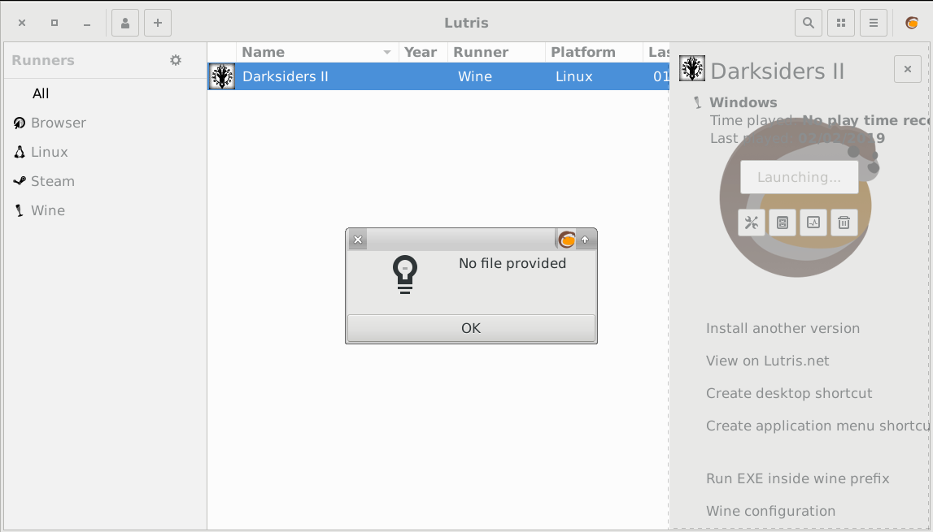
- Said eff it and went to remove the game and this, this is the default option? Really?
  - 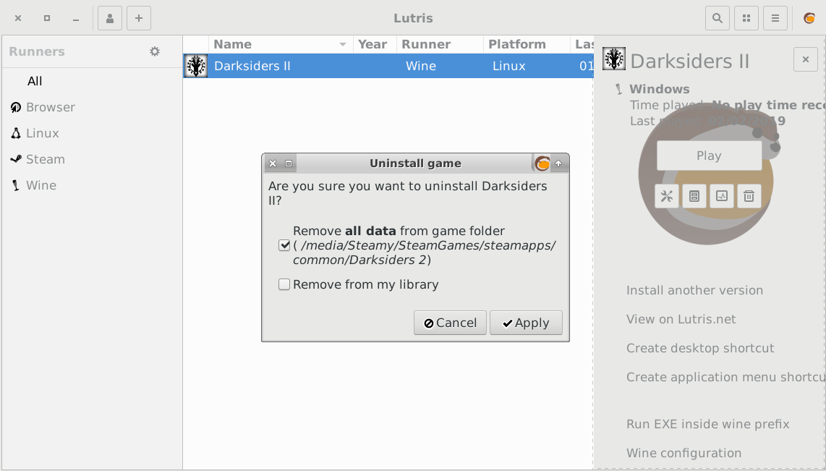
- That should not be the default option.
- Thus concludes my Lutris 0.5.0 adventure.
- I’ve been using the .5.0 Beta for a while and aside from some of the usual installer fuckups, no real issues
- Not sure if I like the right side panel, but that’s just my particular aesthetic

Vulks
https://blogs.unity3d.com/2019/01/31/unity-2019-1-beta-is-now-available/
https://unity3d.com/unity/beta/2019.1/#release-notes
- Dropping 32bit Linux for the sake of focusing on 64bit and improving as much as they can, without that lasso around their neck.
- Vulkan improvements are certainly welcome after what we’ve seen from games like Ballistic Overkill, which perform the same or marginally worse with Vulkan rather than GL.
- There are a whole mess of linux fixes in here, which is something to appreciate given other Engines don’t really do much to support us
- That’s 22 mentions of Linux in the release notes, which is certainly considerable.
- These are divided between both the engine itself and the editor.

Cross Ultima
https://crossuo.com/
- It, won't, die.
- It never will. Between this, ever crack and ragnarok
  - Runescape. You forgot Runescape!
    - But I already escaped. Don’t make me run
- Manjaro packages? Really? Also not setting permissions in your tarball

FPZ
https://www.moddb.com/mods/zelda-tc
- DOOM with Links.
- I really like dumb experiments like these
- Unintentional Minecraft is unintentional
- Nintendo’s lawyers are gonna have something to say.

Orange
https://github.com/bvschaik/julius
- Supposedly this is just a binary replacement,so you can drop the compiled version into your Caesar 3 Install directory and just go
- The OG game is 8 bucks on steam

CHAIRQUISITION:
- Nooope
- Not sure if want
- Check it out
- Shutupandtakemymonies

Game: Mage's Initiation: Reign of the Elements
Webzone: Mages_Initiation_Reign_of_the_Elements
Devel: Himalaya Studios
Engine: Adventure Game Studio
Price: £11.39 / US$14.99 / CA$17.49
Wazzat: Join D'arc on a perilous journey across the medieval-styled land of Iginor. And ascend beyond the lofty mountain peaks where the mysterious and hostile Flyterians dwell, suspicious of all outsiders. It is time for D'arc to prove himself.

Mandatory Disclosure:

Pass|Fail 


Venn:
Does It Launch
- It launches, somewhere between my UHD and 1080p monitor at a 2160p+ resolution in a window that cannot be resized.
- Same things in fullscreen, minus the window.
- Proton to the rescue.
Performance @ 1080

Graphics

Control


Jordan:
Does It Launch
- Gotta play it in windowed mode if you want to actually see what’s on screen
- Lo and behold the game files actually contain a readme which tells you where the linux configuration files are
- Unfortunately, they make it clear that the only way to fix the game’s fullscreen issues in Linux and OSX in to change screen mode from the menu you can’t use in fullscreen mode because it’s chopped off
- You could theoretically get the proper configuration and share it, but I don’t have the wherewithal or inclination to do that
Performance @ 1080
- Rocking that 46 fps. G sync yo
Graphics
- They did a good job of capturing that sierra king's quest feel
- The dialogue especially
Control
- There is no adjustable mouse acceleration and it’s fucking terrible


Pedro:
Does It Launch
- It launches well enough, in Windowed mode.
- You don’t get an option to set the resolution in Windowed mode.
- In Fullscreen mode the game appears ¾ of the way to the right of my UHD monitor and the last quarter is chopped off.
Performance @ 1080
- I guess that’s as high a FerPS as we get, then.
Graphics
- It’s a 2D point and click adventure.
- Though a few more resolution options would have been handy.
Control
- The mouse movement is a bit off but it’s certainly better than what it was originally.
- Where it would only take 5 X11 inputs per second.

QA Score:
Fedora:
Soulless:
Ubuntu:

Fun section:
Fun?:
- Venn:
  - Over ten years in the works and $125,174 of wet stinky Kickstarter cash.
  - We get something that’s a Quest For Glory’ish point-and-clicker.
  - Ya gotta collect three things because reasons, the game.
  - Pointing and clicking.
  - Tedious dialogue.
  - Hella backtracking.
  - Clunky interface
  - A character that that walks on the backdrop, not really in it.
  - At least you can WASD and Shift run.
  - Combat is point and clicky.
  - This is absolutely faithful to the games of old even down to dicking with config files in an effort to make the fkr work.
  - The thing is Brad, I don’t miss any of that.
  - Himalaya Studios did a great job recreating the DOS ages but those are not times I look back on with kindness.
  - Retro to a fault.
- Jordan
  - Well, the game goes out of it’s way to make itself look and feel like a sierra style king's quest game and it definitely succeeds
  - However, king's quest steadily advanced technology wise and started to leave a lot of those anachronisms it used in the past
  - And that’s where I feel the gameplay falls shortest. Nostalgia trips like this need to identify the stuff that made those old games good and apply modern design sensibility to them.
  - Those of us who played the older games had to suffer through it due to technical limitations that no longer exist and can alienate new players
  - Thimbleweed park actually does a very good job about this
  - But hot damn, does this game control like a butt, all that context aside
  - When I play old games through dosbox, scumm or anything like that, it doesn’t slow my mouse down to a crawl
  - Also, kindly don’t hide configuration options for screen resolution behind a startup menu that will disable things it view as “useless”
- Pedro
  - I can safely say I’m not a fan of the combat system.
  - Since it is a point and click adventure, I feel like maybe a turn-based combat system would have been better.
  - Maybe something like the Might & Magic series did back in the day.
  - In Mage’s initiation, I can’t help but feel like a real time combat mechanic is a little bit out of place.
  - Though, outside of combat, I think this could very well be a nice retro hipster point and click.
  - It certainly does have the Sierra King’s Quest style going for it, as Jordan mentioned.
  - And that’s a very good place to be for what they’re going for.
  - The dialog isn’t terrible and the voice acting is just slightly on the stilted side, which fits in with the olden timey style perfectly.
  - I just wish they had figured out how to fullscreen.

Fun Score:
Venn:
Jordan:
Pedro:

Hate Mail:

Speed
https://linuxgamecast.com/bradley/?FI9td4z

Punk
https://linuxgamecast.com/bradley/?Sa3Dzm2
https://www.kickstarter.com/projects/insertdisk22/602274859?ref=640222&token=2b4f8937
https://insertdisk22.itch.io/born-punk-kickstarter-demo
- .vs files?
- Seems to be made with visionaire-studio.
- Eats a dick while looking for libavcodec.

After:

